Redmink Productions
presents
Hollywood Lookalikes

- Humphrey Bogart
- Charlie Chaplin
- Russell Crowe
- Cher/Female Impersonator
- Daniel Craig/James Bond
- Elvis
- W.C. Fields
- Jamie Foxx
- Judy Garland
- Oprah
- Liza Minelli
- Marilyn Monroe
- Dolly Parton
- Regis Philbin
- Austin Powers
- The Rat Pack
- Lucy Ricardo
- Ricky Ricardo
- Joan Rivers
- Sex & the City
Ladies
- Tony Soprano
- Britney Spears
- Liz Taylor
- John Travolta
- Mae West
- Captain Jack Sparrow
- Spiderman
- Batman
- Superman
- Groucho
- Howie Mandel
- Gilligan’s Island
- Ozzy Osborne

The Rat Pack
Chicago Characters

- The Blues Brothers
- Harry Caray
- “Shoeless” Joe Jackson
- Ol’ Lady Leary
- Potter & Bertha Palmer
- Mies Van Der Rohe
- Frank Lloyd Wright

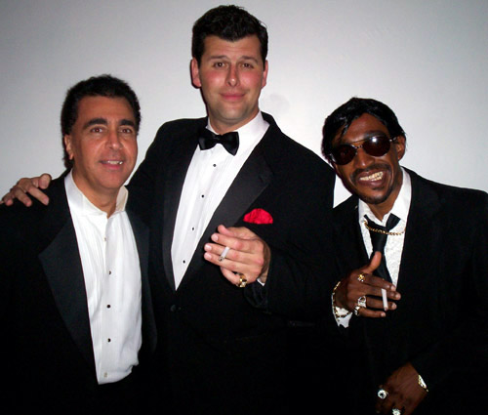

The Blues Brothers

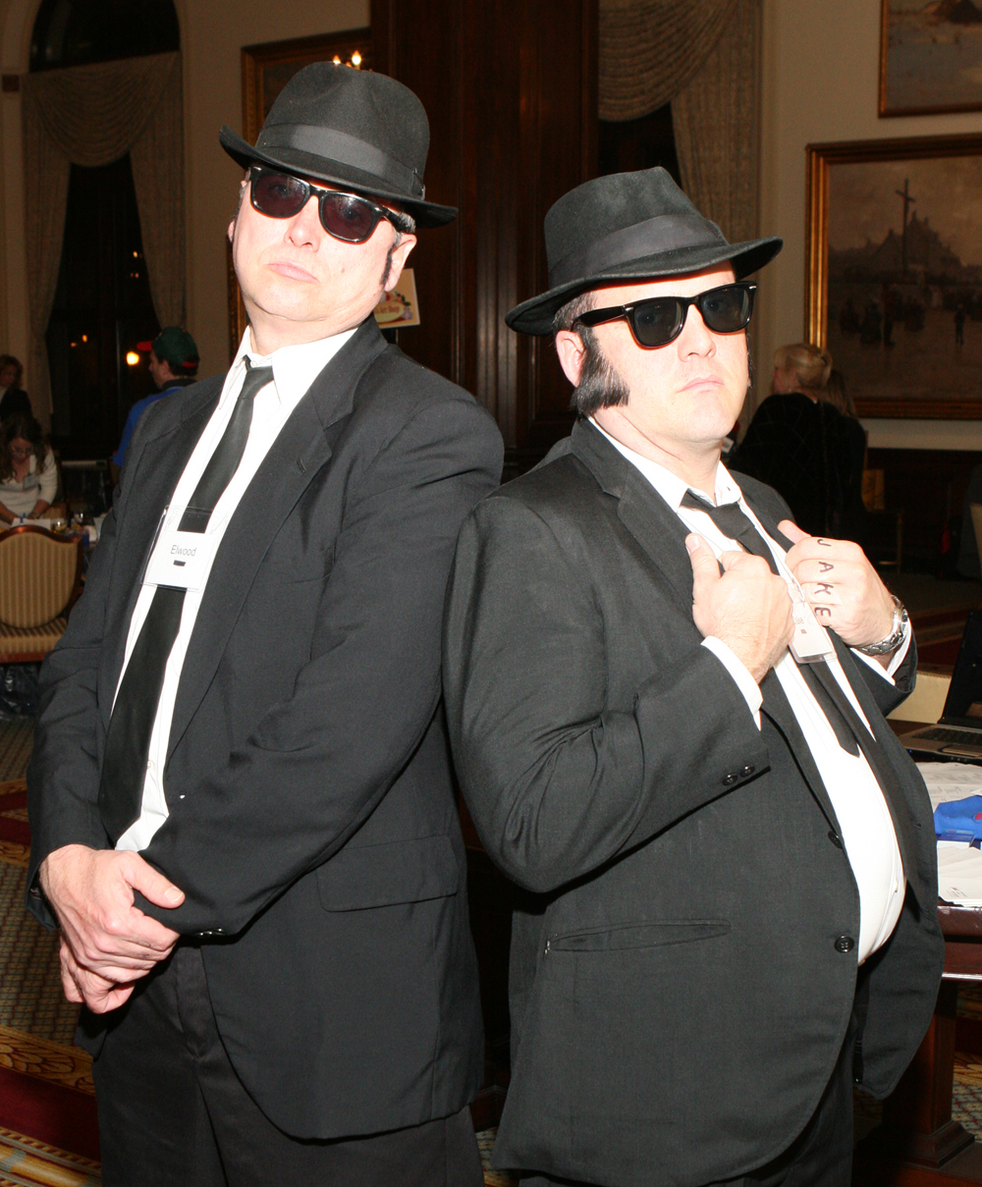

Historical Lookalikes

- Ben Franklin
- Stephen Douglas
- Abraham Lincoln
- Mary Todd Lincoln
- Teddy Roosevelt
- George Washington Carver

Redmink Productions uses actors with strong performance skills and theatrical experience as their lookalikes, giving added entertainment value. Redmink can also write scripts and design evenings for your specific event or trade show.
Redmink Productions

5501 W. Byron www.redmink.com 773-685-1818
Chicago, IL 60614 redmink@mac.com 773-685-1836

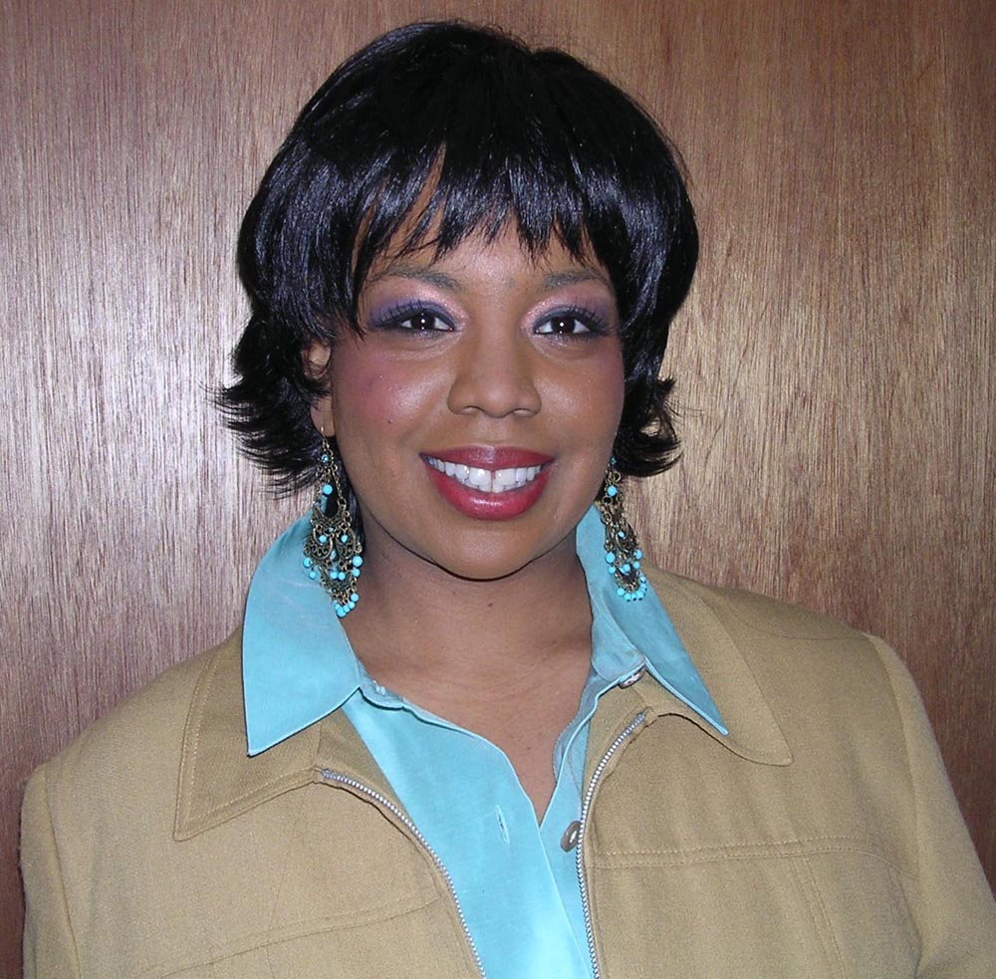

Oprah

