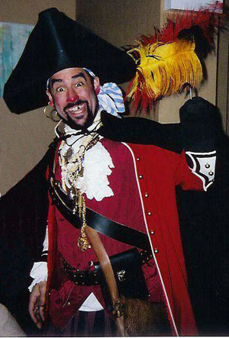
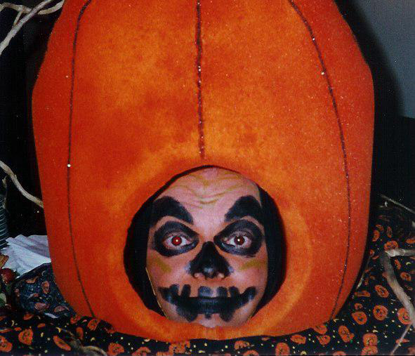
Creep You Out!
Other
Tricks 'N' Treats



Psychics

‘Li’l Devil
Beetlejuice

Vampires
Monster Caricaturists

Morticia and Gomez
Creepy Critter Corral
Spandex monsters
Frankenstein

Jolly Roger Pirates

Pumpkin Head Stiltwalker

Dead Victorian Bride and Groom
Bride of Frankenstein
The Headless Horseman
Halloween facepainters
Talking Pumpkin Buffethead

Wolfman
Skeleton
The Mummy
Scarecrows
Ghouls
Black Cats

Ghosts

Witches
Scary Characters and Stuff!

Let Redmink Productions
Music
Murder Mysteries
Theme Nights
Scavenger Hunts
Ghostly Storytelling
Psychic Fairs


5501 W Byron
Chicago, IL 60641

Redmink Productions
www.redmink.com
redmink@mac.com

Phone 773-685-1818
Fax 773-685-1836

