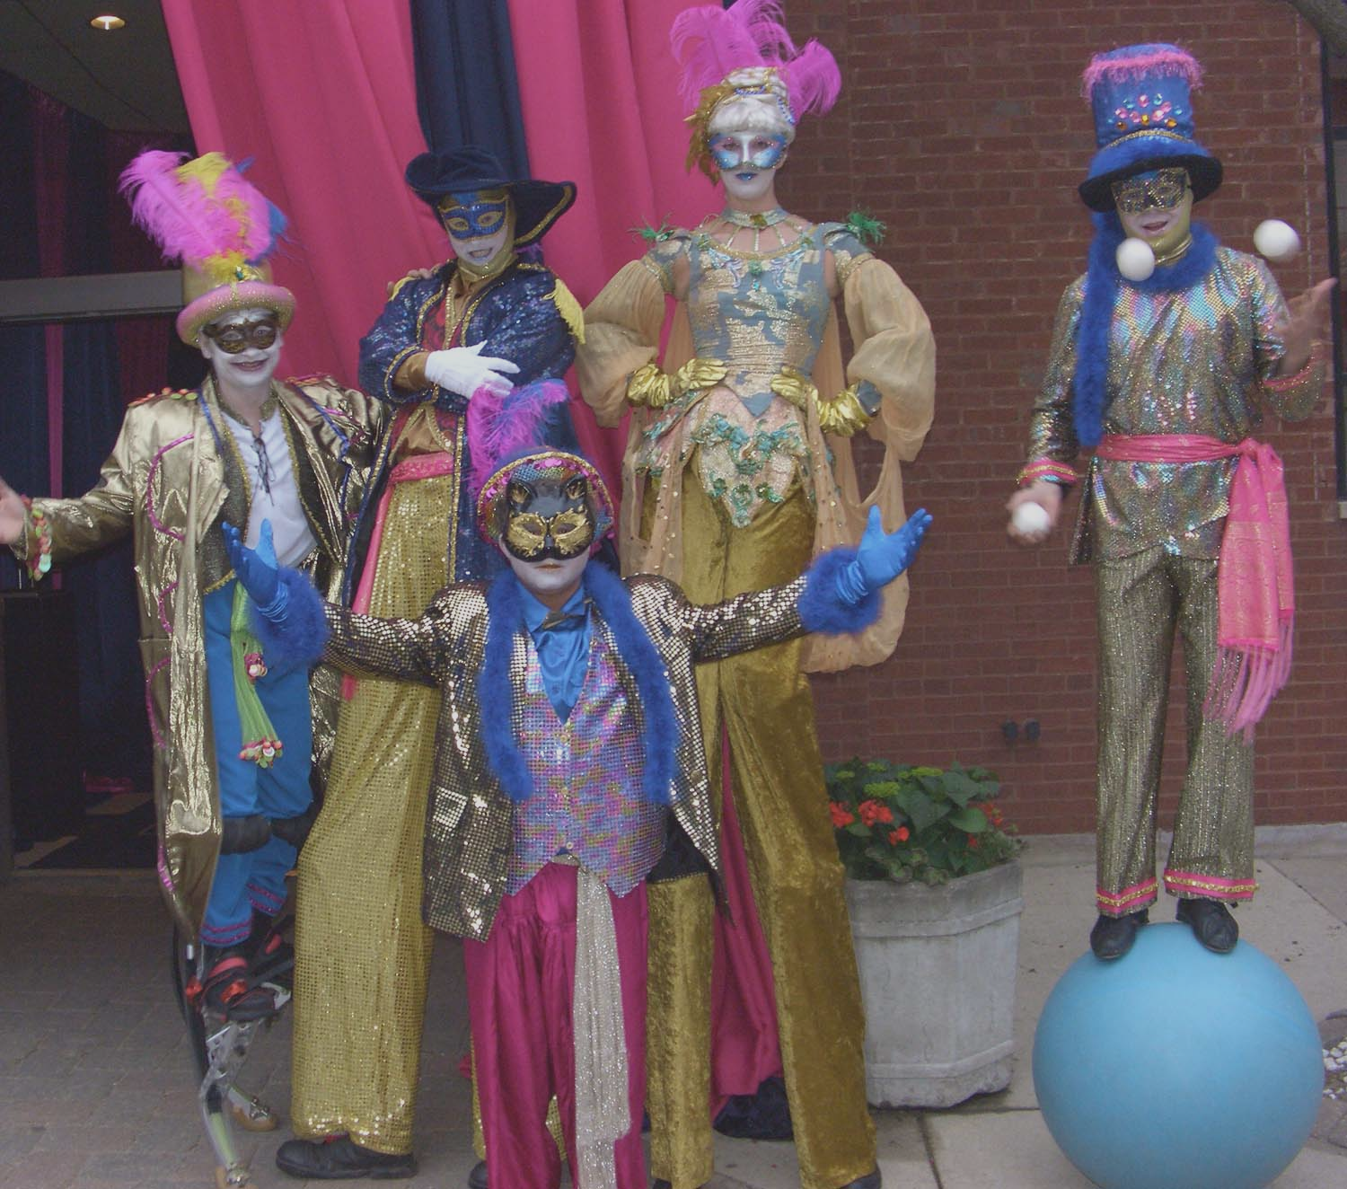
Redmink Productions
Performers:
Redmink Productions

5501 W. Byron www.redmink.com 773-685-1818
Chicago, IL 60614 redmink@mac.com 773-685-1836
Redmink Productions can design a comedic or sophisticated interactive evening with any of the following themes, as well as provide individual performers. Redmink can add comedic scripting, customizing, music, mystery, games, or a scavenger hunt to nearly any theme. We also costume all of our performers to fit the theme. Many of our performers have excellent individual shows!

We have music to enhance all of our themes, as well as dance bands for any event!

- Moulin Rouge
- Oktoberfest
- Peter Pan
- Renaissance
- Safari
- Speakeasy
- Sports/Olympic
- Tropical
- Victorian Christmas
- Voo Doo Nights
- Willie Wonka
- Wild West
- Winter Wonderland
- Wizard of Oz
- World’s Fair
- 30’s Supper Club
- 40’s Swing
- 50’s Grease
- 60’s Flower Power
- 60’s Rat Pack
- 70’s Disco

- Academy Awards
- Americana
- Carnivale
- Chicago/Blues
- Circus
- Cirque du Soleil
- Clue
- Fairy Tale
- French Cabaret
- Futuristic
- Harry Potter
- Havana Nights
- Italian Masquerade
- Las Vegas
- Mardi Gras
- Medieval

- Acrobats/Aerial
- Actors
- Balloonists
- Carolers
- Caricaturists
- Circus Arts
- Clowns
- Comp-U-Sketch
- Crafts
- Dancers
- DJ’s
- Facepainters
- Fire Eaters
- Henna Tattooists
- Hypnotists
- Jousters
- Jugglers
- Living Statues
- Lookalikes
- Magicians
- Mimes

- Musicians
- Photographers
- Plate Spinners
- Puppeteers
- Psychics
- Santas
- Silhouette Artists
- Stiltwalkers
- Storytellers
- Stunt Performers
- Swordsmen
- Talking Buffetheads
- Tattoo Parlours
- Ventriloquists

