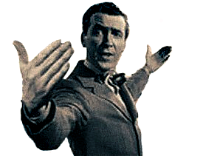




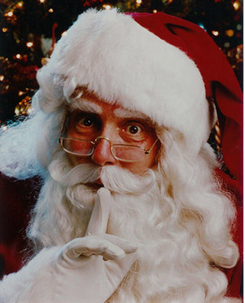
Old Man Potter’s Picks

Clarence the Angel's Acolytes
Shhhhh!
Non-holiday themes, too!
Classic Ring
Carolerss
- Victorian Christmas
- Nutcracker Suite
- Willie Wonka
- Winter Wonderland
- Christmas Around the World
- Candyland
- Live Music
- Scavenger Hunts/Teambuilding
- Games and Game Shows
- Animal Shows
- DJs

- Actors/characters
- Aerial Performers

Balloonists
- Caricaturists
- Contortionists
- Dancers
- Facepainters/ airbrush

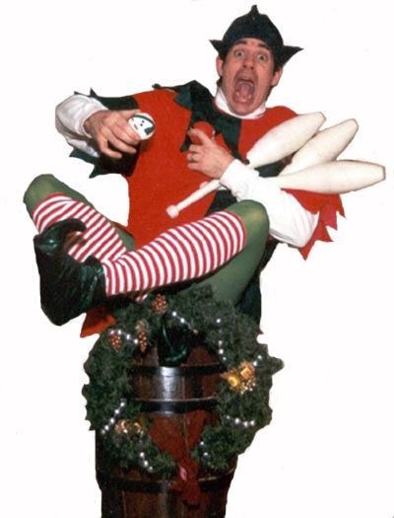

- Hollywood Lookalikes
- Henna Tattooists
- Mentalists
- Jugglers
- Puppeteers

- Psychics
- Spandex performers
- Silhouette artists
- Stiltwalkers/Spring
- Storyteller
- Living Statues
- Magicians
- Mimes
- Musicians
- Photographers
- Rolling Globe

5501 W Byron

Chicago, IL 60641
Redmink Productions
www.redmink.com redmink@mac.com

Ph 773-685-1818
Fx 773-685-1836

Uncle Billy’s Best

Classic Ring Carolers
Living Ornaments
Santa and Mrs. Claus
Talking Xmas Tree Buffethead
Scrooge and Tiny Tim
Chimney Sweeps
Wind-Up Toys
The Grinch
Rudolph
Elves
Holiday Dolly
Snowflakes
Christmas Angel
Nutcracker Suite Characters

Bert And Ernie’s Favorites
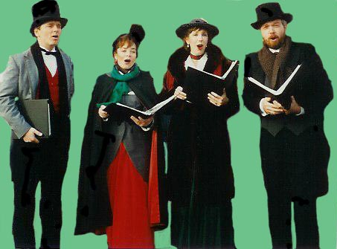

SHOWS
AVAILABLE!

